Process of Fine-tuning a Phi-4 Models in HuggingFace Space (Jabez)
Hardware:
To install unsloth, you need to have CUDA in your environment.
So, we have a line where we get the image from Docker hub and create a container for it

Environment
Full Requirements: https://github.com/unslothai/unsloth
One of the requirements for installing Unsloth is to have your python version to be > 3.9
For example, our container python version is 3.11
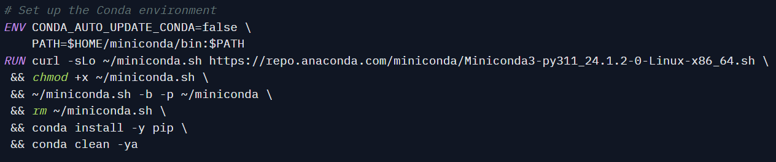
Another requirement is Pytorch
You can the installation command from:
https://pytorch.org/get-started/previous-versions/
WARNING: Due to Unsloth dependencies, Unsloth only worked with some CUDA version and Pytorch version so make sure to read the Unsloth Documentation.
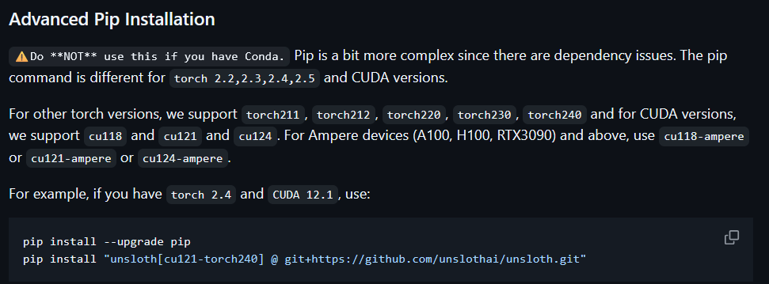

For example, our container has CUDA 12.8 and Pytorch 2.7.0
Import Module
If you can install unsloth, you can see this
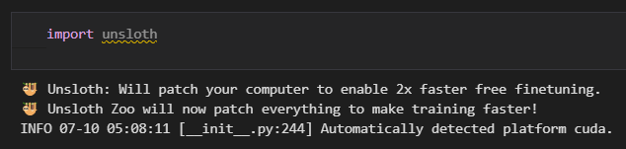
Install requirement.txt
jupyterlab==4.2.5
tornado==6.2
ipywidgets
unsloth>=0.3.0
vllm
torch>=2.0.0
transformers>=4.36.0
datasets>=2.14.0
trl>=0.7.4
accelerate>=0.24.0
bitsandbytes>=0.41.0
scipy>=1.11.0
click>=8.0.0 # Required by wandb/trl
wandb>=0.15.0 # Optional but good to have explicitly listed

Turn off some Optimization
Due to how recent Unsloth library is, there some optimization we need to change to fine-tune the model.
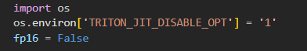
This disables Triton JIT optimizations in PyTorch. It helps avoid numerical instability or compatibility issues during model training or fine-tuning with frameworks like Unsloth.
The “fp16 = false” sets the precision mode to full precision (FP32) instead of half precision (FP16). It useful for avoiding potential underflow/overflow issues during training.
The “modeling_utils” is internal utility module from Hugging Face's Transformers library.
That code ensures ALL_PARALLEL_STYLES is defined, which lists the valid model parallelism strategies and adds support for different weight distribution strategies like:
- "tp": tensor parallelism
- "colwise" and "rowwise": column-wise and row-wise partitioning
- "none": no parallelism
It’s required by Unsloth for compatibility with some versions of the Transformers library that may lack this attribute.

Import Phi-4 model
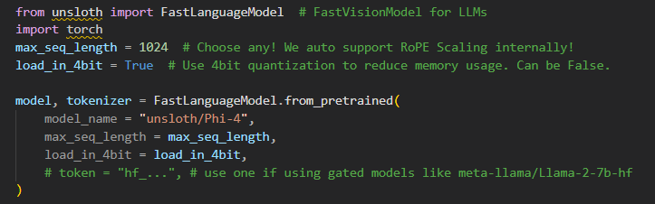

We use the FastLanguageModel from the Unsloth library to import the LLM—in this case, Phi-4. The max_seq_length defines the maximum input sequence length. Due to a known Triton issue, it is recommended not to exceed 1024. The load_in_4bit option enables 4-bit quantized loading to significantly reduce VRAM usage.
Enable Lora adapter
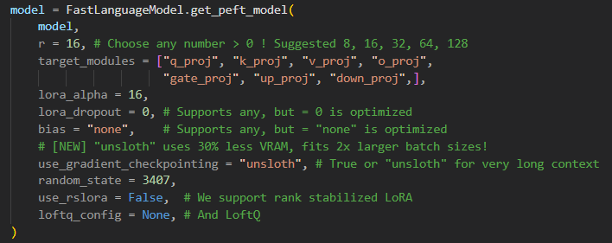
We apply LoRA using “get_peft_model()” from Unsloth to enable parameter-efficient fine-tuning. The r value is set to 16, which defines the rank of the low-rank adapters. LoRA is applied to projection layers listed in “target_modules”. “lora_alpha” scales the LoRA updates, while “lora_dropout” and bias are set to optimized values for better memory usage. “use_gradient_checkpointing” is set to "unsloth" to support longer input sequences with reduced VRAM. Additional options like “use_rslora” and “loftq_config” are disabled in this setup.

Data Preparation
Combine all imported JsonL to one dataset
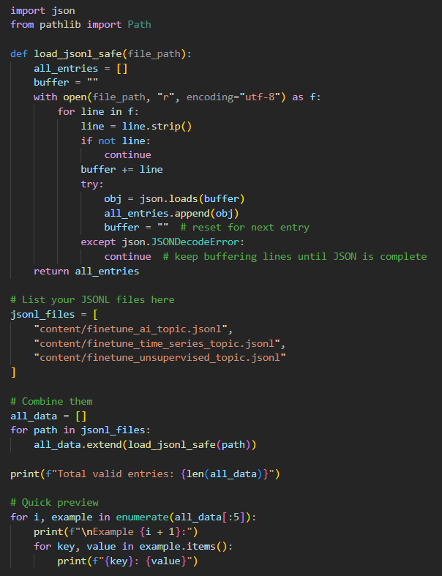
We define a helper function "load_jsonl_safe()" to safely read ".jsonl" files line by line. This approach ensures incomplete JSON entries are skipped and properly parsed. Three fine-tuning datasets are loaded from the "content/" directory, each covering different topics (AI, time series, unsupervised). The entries are aggregated into a single list, and a quick preview prints the first few examples for validation. This preprocessing step is essential to prepare the training data for instruction tuning.
Import the tokenizer for Phi-4
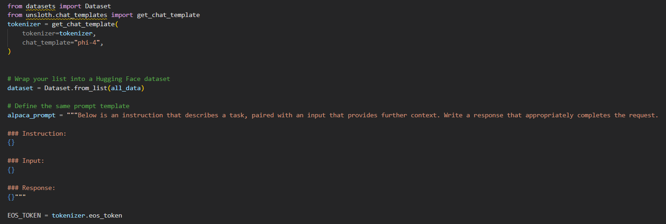
We define the tokenizer using "get_chat_template()" from the "Unsloth" library, specifying "phi-4" as the chat template to match the model's format. This ensures that the tokenizer will format prompts correctly during training. The loaded training data ("all_data") is then wrapped into a Hugging Face Dataset object. Additionally, a consistent prompt format ("alpaca_prompt") is declared to structure each training example with "Instruction", "Input", and "Response" fields. This setup ensures alignment between the model, tokenizer, and fine-tuning data.
Format the dataset with the tokenizer
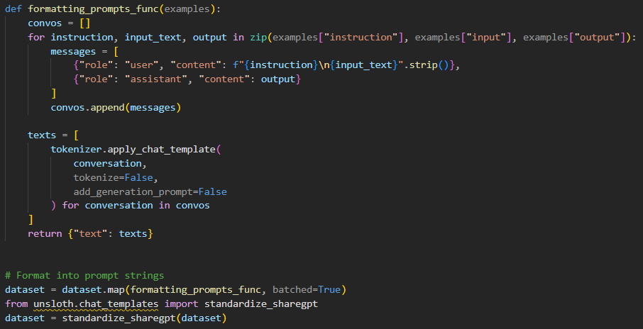
We format the dataset into a prompt-response structure using "formatting_prompts_func()". Each example is converted into a conversation-style message, where the user's input includes both the instruction and context, and the assistant provides the expected output. The tokenizer's "apply_chat_template()" function wraps each example in the correct format expected by the Phi-4 model. After mapping the formatting function across the dataset, we apply "standardize_sharegpt() "from Unsloth to ensure compatibility with ShareGPT-style conversational formatting.

Start the FineTune
Define the training parameters
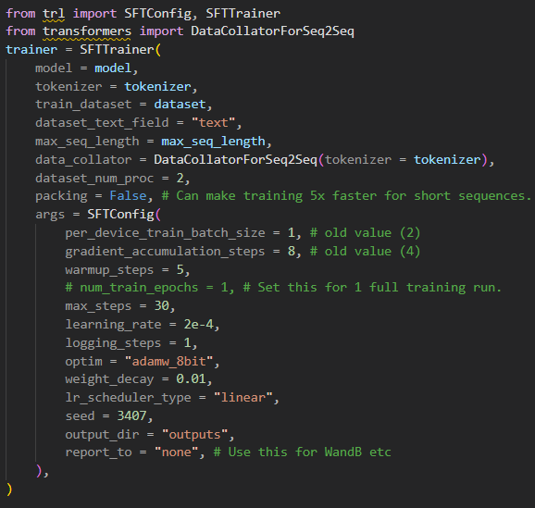
We define the training configuration using SFTTrainer and SFTConfig from the trl library. The fine-tuning dataset is passed along with the tokenizer and model. Training parameters are specified within SFTConfig, including:
- per_device_train_batch_size = 1: mini-batch size per GPU
- gradient_accumulation_steps = 8: simulates a larger batch size
- learning_rate = 2e-4 and weight_decay = 0.01: optimizer hyperparameters
- max_steps = 30: total number of training steps (instead of epochs)
- warmup_steps = 5: warmup for learning rate scheduling
- optim = "adamw_8bit": uses 8-bit optimizer for memory efficiency
- output_dir = "outputs": where model checkpoints will be saved
- report_to = "none": disables logging to external tools like Weights & Biases
The setup also includes DataCollatorForSeq2Seq and sets packing=False, meaning sequences are padded instead of concatenated.

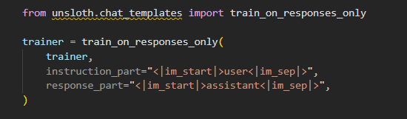
We apply train_on_responses_only() from Unsloth to configure the trainer to focus solely on learning the assistant's reply. This is done by specifying the special token markers:
- instruction_part: identifies the user message section.
- response_part: identifies the assistant’s response section.
This approach ensures that the model is trained only on generating appropriate outputs, while ignoring the loss for the instruction and input parts.
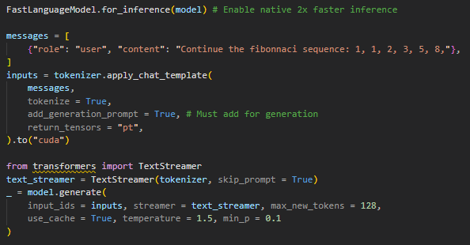
After training, we perform inference using FastLanguageModel.for_inference() to enable optimized decoding. A test message is structured as a chat input (in this case, asking to continue the Fibonacci sequence). The input is formatted using the tokenizer with generation-specific settings. TextStreamer from Hugging Face is used to stream the output tokens live. The generation is performed with parameters like temperature = 1.5 and min_p = 0.1 to encourage creative sampling. This confirms that the model is functioning and can generate completions based on user prompts.

Example completion:
The Fibonacci sequence is a series of numbers where each number is the sum of the two preceding ones, usually starting with 0 and 1. In this case, the sequence starts with 1 and 1.

The next number in the sequence is found by adding the last two numbers. So, to find the next number after 8, we add 5 and 8 to get 13.

Continuing this pattern, the next number is found by adding 8 and 13 to get 21.

The next number is found by adding 13 and 21 to get 34.

Save the Model
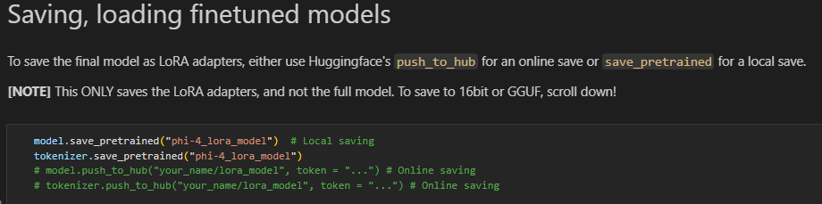
To use back the adapter again
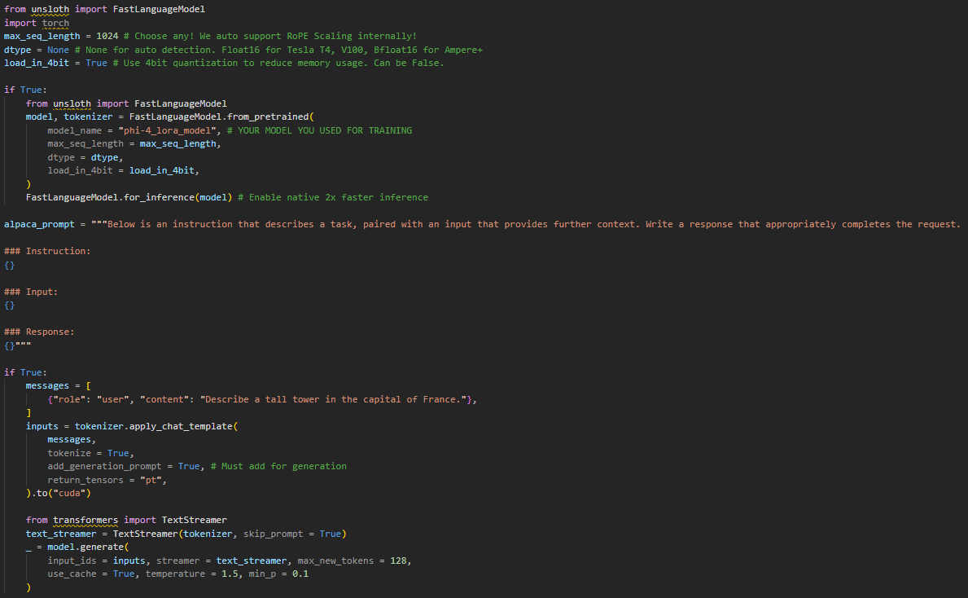

APPENDIX
File: dockerfile (dir: .....)

